# **Configuring the Flight Controller**

**Main Documentation:** <http://ardupilot.org/copter/docs/common-pixhawk-overview.html>

## Introduction to Pixhawk:

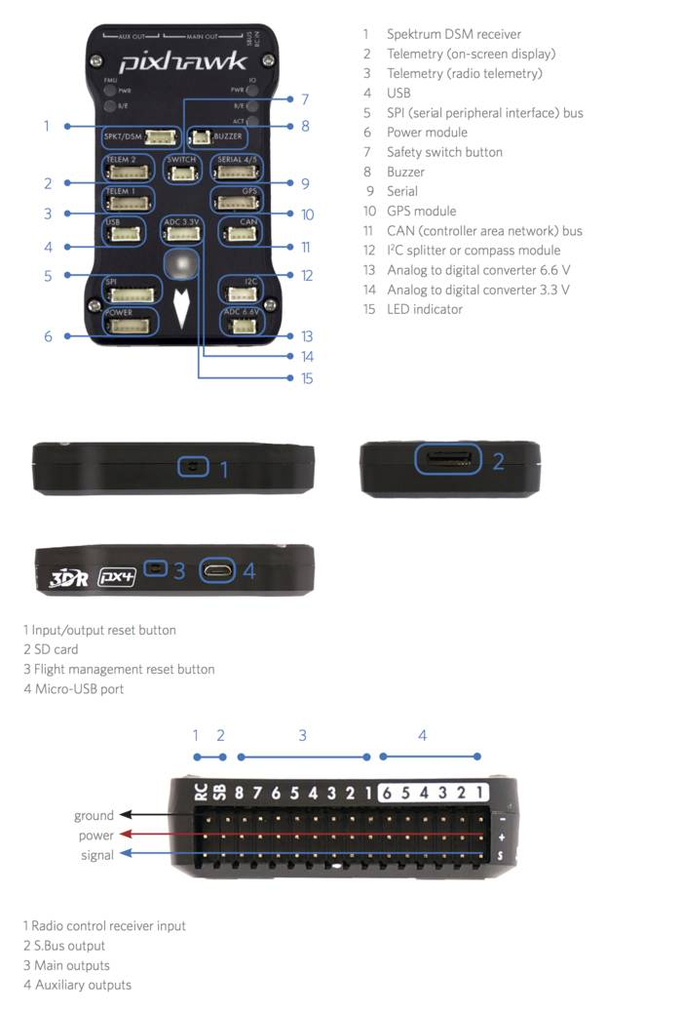

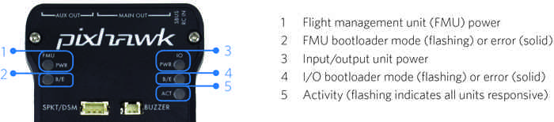

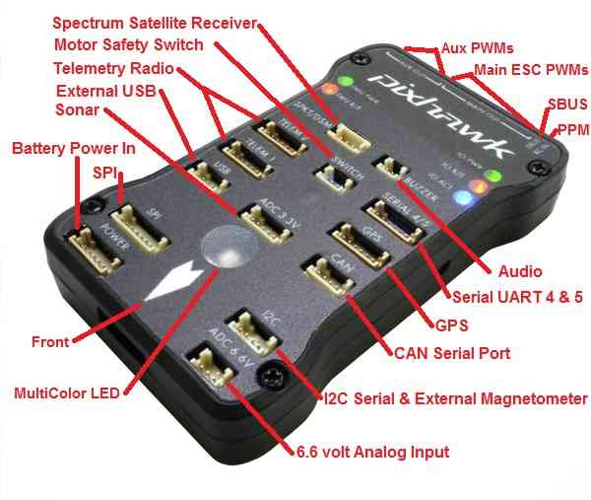

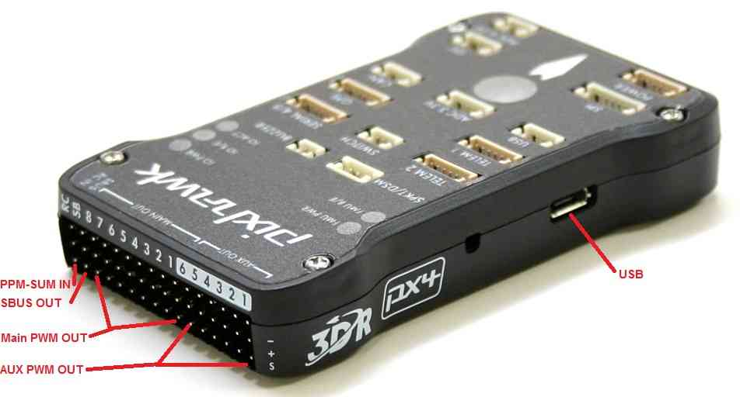

## Connections

1. Insert the buzzer and the switch in their respective slots
2. Connect the usb cable to the micro usb port
3. If the GPS module is provided with 5 wire connector as required by APM flight controller, remove the wires from the connector and insert them in the 6 pin connector provided as shown below. Make sure to have two empty slots between the green and black pins. Now connect the GPS plug into the GPS port and the smaller port into the I2C port.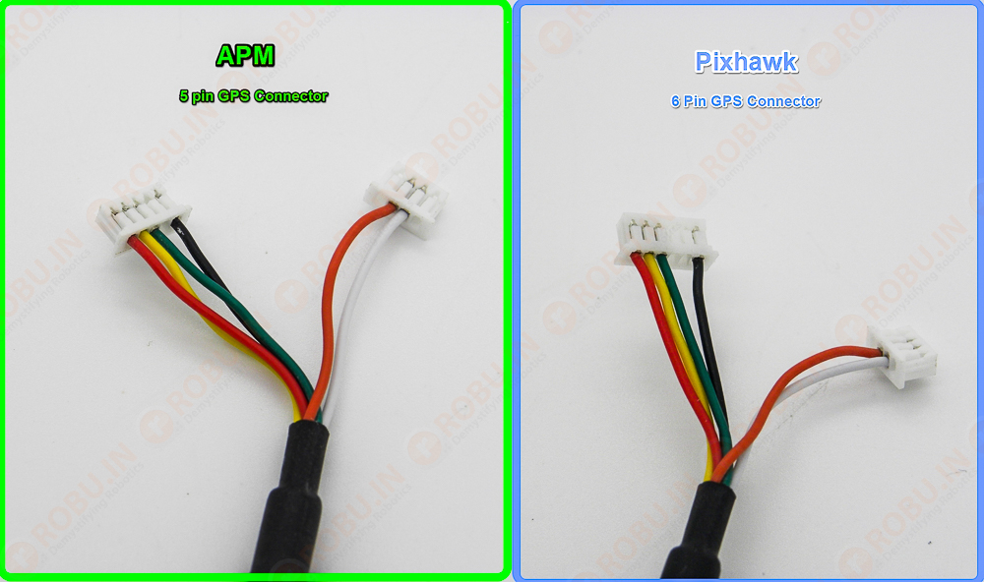
4. Now connect the receiver to the pixhawk through the PPM encoder. One servo plug goes to the RCIN port of the pixhawk ensuring proper orientation. The other servo pins go to the receiver in serial order(channel 1 of PPM encoder goes to channel 1 of the receiver and so on).
5. Connect the ESC servo plugs into the Pixhawk following the images below: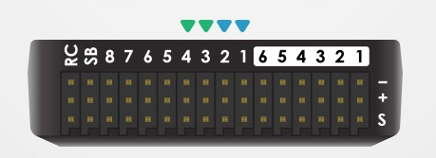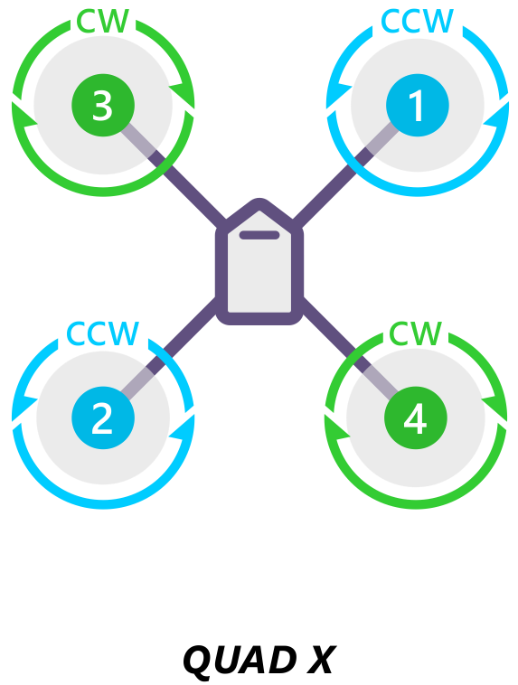

## Download and install Mission Planner:

1. Download the mission planner from the link given below

<http://ardupilot.org/planner/docs/mission-planner-installation.html>

1. Install everything. During startup when asked to load altitude management press **NO.**

## Installing the firmware:

<http://ardupilot.org/copter/docs/common-loading-firmware-onto-pixhawk.html>

**Note:** To connect the flight controller to the Mission Planner select the COM port to auto.

**Note:** The firmware is installed once into the pixhawk and does not need reinstallation. Only in the case of changing the model we need to reinstall the firmware.

**Note:** Make sure to hear the music after connecting the USB port before clicking the connect button in the mission planner.

## Hardware Configuration and Calibration:

<http://ardupilot.org/copter/docs/configuring-hardware.html>

**Note:** For compass, calibration choose relaxed mode instead of default if it fails regularly.

## Arming and Disarming

1. Keep the quad on a leveled surface and monitor the status LED
2. The LED will flash blue and red after some time indicating gyros are being calibrated. Then a musical tone signifying that gyro has been calibrated and is ready to be armed.
3. **Press and hold the safety switch until it becomes solid red**. You will hear a sound and the status LED on pixhawk will flash blue.
4. Hold the throttle stick to the lower right corner for 5 seconds and you will hear a long beep meaning it has been armed. The status LED will become solid blue.
5. Now you are ready to fly
6. To disarm the quad land it first and **wait for the motors to stop.** Then hold the throttle to the lower-left corner for 2 seconds you will hear a beep and the status LED goes back to flashing blue.

**Note: Please ensure the motors stop before disarming the quad. An attempt to disarm when the motors are still running will lead to uncontrolled yaw and may claim your life.**

**Making a Kill switch:**

1. Change PPM encoder wiring from 6 to 7 leaving the pin 6 unconnected.
2. In mission planner configurations go to advanced parameter tuning.
3. At the bottom left corner, you will see options for ch7-aux, change that to Arm/Disarm and write params.
4. Now you can arm or disarm the quad any time(mid-air) using this switch.